Designing Environments for Brainstorming
- Final Project Report
Yingdan Huang
Peng Michael Shao
Praful Mangalath
Chen-Chung Liu

Introduction

We are investigating collaborative environments that support early phase design. The emphasis is on investigating and proposing online application prototypes that addresses problems we faced with existing environments. The thing that is immediately apparent to us after trying to mimic and improve existing environments discussed in our presentations is that connecting people in rich media environments is a hard task and tools/paradigms can be extended to their breaking point and yet not deliver as natural a user experience, as say using slides/documents to present facts.

We have explored various frameworks optimistically hoping to find a clean way to develop on our design intuitions and rejected equally many ideas as we are constrained by time.

Preliminary Analysis

Based on the observations from Brainstorming Experiments 1 and 2, we came up with a preliminary list of features for prospective online brainstorming applications:

• Start with individual brainstorming, then presentations, then group brainstorming, then group idea reduction.
• Support different kinds of representation media (text, various sizes post-its).
• Support rapid iterative drafting.
• Support observation of other individuals during individual brainstorming.
• Support constant feedback loops.
• Support audiovisual communication, especially during group brainstorming.
• Support note taking distinct from sketches.
• Support a public workspace (whiteboard) in addition to private workspaces (desk).
• Support colors insofar as it tracks each individual’s contributions.
• Support the presence of a moderator to maintain discussion focus.

Constraints

This was a relatively informal experiment exploring the characteristics of a narrow scope of group brainstorming activities. The brainstorming activities here were of the synchronous, localized, and short term nature. Furthermore, our discussions were improvisatory – the participations had no knowledge of the discussion topics beforehand – rather strange candidates for a brainstorming session.

To keep the project deliverables feasible – we decided to concentrate on a small subset of features.
- synchronous rich-media sessions
  - chat
  - audio
  - video
- annotation schemes - sketching
  - whiteboard
  - wiki-whiteboard comment
- track and organize brainstorming sessions
  - search
  - content management

The basic deliverable will be database-driven dynamic web environment prototypes that address these features. To quote Tim O’Reilly in the paper “What Is Web 2.0: Design Patterns and Business Models for the Next Generation of Software:
“At bottom, Google requires a competency that Netscape never needed: database management.”

In both brainstorming experiments that we conducted, we noticed that it was very interesting how people interacted with each other and how information was exchanged (with a fair amount missing in a traditional brainstorming session). A database can not only collect all this information but manage it in a way in favor of the design issue.

Rather than battle language preferences and integration we tackled these features at separate levels leaving environment integration out of the deliverable. Yingdan worked on synchronous media rich sessions and has delivered an environment which allows groups to login to an online environment that supports text-based chatting, voice char and a neutral xml export of the entire session. Mike tackled the problem of sketching and annotation sessions and has delivered a prototype which allows groups to upload images, sketch and annotate images/sketches online again allowing session data into an xml dump. Praful worked on asynchronous brainstorming sessions, allowing files from both sessions to be uploaded along with supporting popular document formats (open document format), idea snippets and code samples to be shared and viewed online without having to download any of the files locally. The wiki also supports annotating these documents with tags and has a concept cloud feature that allows popular concepts to surface from the brainstorming session. The details of these prototypes are discussed below.

We started with a simple relational database and explored features of dynamic websites. Currently one prototype website is for people to join one or more hobby group(s) and chat online.

I started with a simple relational database and explore features of dynamic websites. Currently my website is for people to join one or more hobby group(s) and to communicate online (Figure 1).
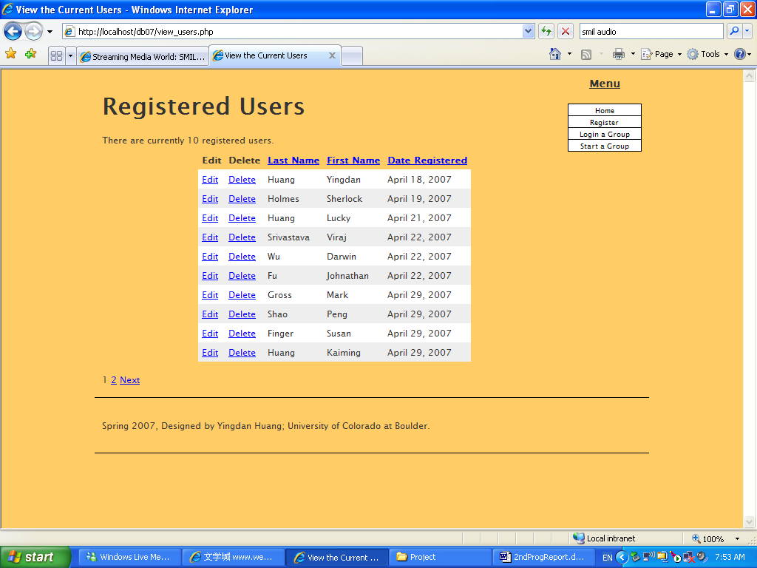
Current Features:
Figure1. Snapshot of viewing registered users
You could:
- register to the website and start a new hobby group
- join a current group and chat with people online
- save chatting record as XML files after logging out

Future Features
You will be able to:
- share and manipulate image, audio/video with your friends

I use the famous Apache - PHP – MySQL combination, client-side JavaScript, and XML (XSLT) as neutral files. Apache server has been set up in Linux (Fedora 5) with a domain name (when my laptop is on with Linux). Except for the basic structure of the database and some more advanced manipulation (such as pagination and using sessions), a small achievement is the “Tiny Chat” (Figure 2) implementation that people in the same group can chat concurrently - it is like a primitive version of the chat in gmail. XML files will be generated for a conversation and garbage collection is frequently performed in MySQL after a certain period of time. With these XML files, it gives possibility that we could search for data afterwards.
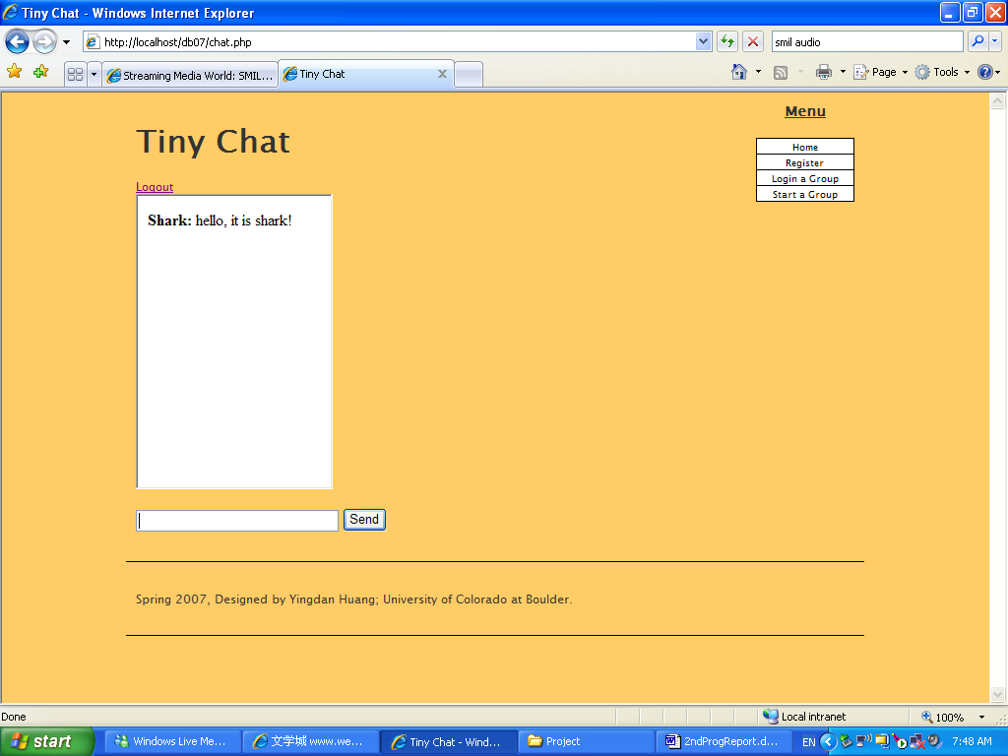
Figure2. Tiny Chat
What I really wanted to do is to get streaming (audio/video) work in a website without any installation. In our team, I am exploring synchronous possibilities in a dynamic website. Because what we intend to do is to give users more flexibility instead of depriving them of the benefits they could obtain from a face-to-face conversation. The inclusion of audio/video could improve the collaborative quality and they could carry rich information, which could be ignored if we only focus on relatively static texts and images.

The progress is not very satisfactory because of many limitations. For example, if we use post-it for a brainstorming session and I would like to add a voice notation to a sticker, JavaScript can’t realize it (it can’t record sound) then I have to turn to Java applet, then how could Java applet communicate with MySQL since we want to share it with other members in the same group as well as to archive it? Probably JDBC would work or Flash could help too, while it will take time to figure out what each of them can do and can’t do.

Besides Tiny Chat, I created Tiny Recorder. It can record sound/voice that is used as a representation beyond text, image and sketch. Since either audio or video provides difficulties in semantic search, it gives the possibility that a user could label each clip with tags. As to this implementation, the immediate problem we identified is that Java Applet can’t easily read/write files to a server because of security and privacy issues. From the perspective of multi-media, if we look at current applications of website, it is not hard to find out the implementations are constrained to some boring level so as to we need to ask several question again and again:
- Is it possible to use one language paradigm for website design?
- What cause the heavy reliance on the usages of script languages for website design (Easy to use? Or historical reasons?)?
- What kind of applications do we want to be online? (For example, if we don’t choose Wikis as our goal, we would prove our concepts much better and faster using traditional environments. Another example is the difference between chatting with gmail and MSN – I prefer MSN even it requires installation and update. )

I am still on the way to explore streaming online. For now, basically I can only say that a simple platform has been set up that we could continue playing on it.

The Scheme
Brainstorming tends to involve short-term collaborations. This project explores remote, asynchronous, short-term collaborations. The main goals of this exercise are to support sketch representation, annotation, and collaboration for brainstorming over sketching.

To support these requirements, the focus is on providing a service that allows continuous information sharing by offering flexible methods of annotation. To this end, three specific features are being developed:

Threads of Posts (“streams of conversation”)
Sketches in Posts (“sketch representation”)
Annotating Sketches (“annotation”)
Dynamic Links (“data hyperlinking”)

The idea is that, at any given point in the brainstorm, users can make a sketch while others add their own sketches and/or critique an existing sketch by annotating it. Critiques follow a “main entry => replies” format much like weblogs. Textual critiques are also allowed and encouraged.

I was motivated by IM brainstorms and discussions with Dr. Repenning that followed the format of streams of conversation that are easy to track and that offer continuous information sharing.

Presently the system supports submission of sketches and work is ongoing to allow users to annotate sketches. To be completed is a prototype on hyperlinking and getting the back-end thread submission working. Work is being done in PHP, XML, and SVG.

Description of Screenshots
Screen 1 - some discussion thread.
Screen 2 - a submit window.
Screen 3 – (crude example) an image is stored and displayed.
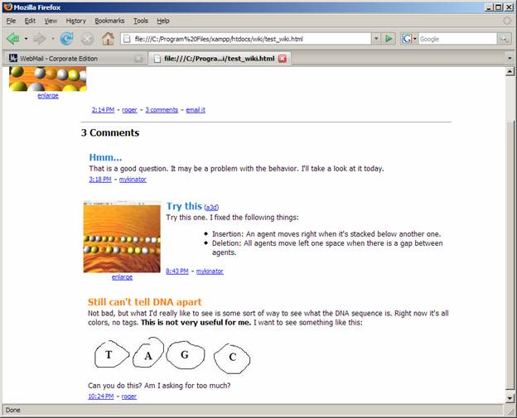
Screen 1

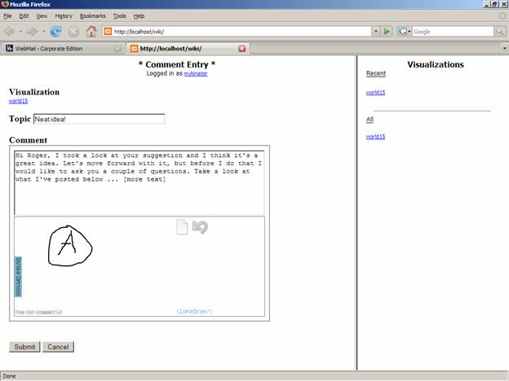
Screen 2

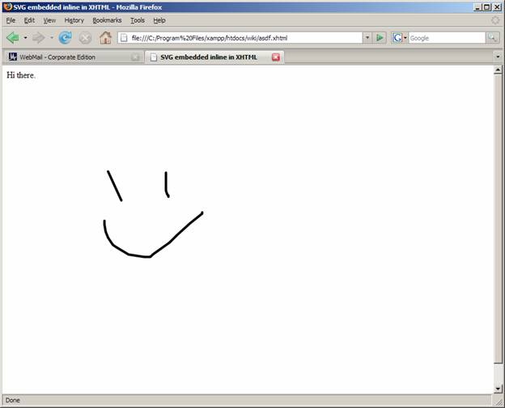
Screen 3

The asynchronous brainstorming session tracking and organization prototype was called – Braindump. It is a wiki type application specifically meant to deal with organizing session contents and viewing documents online. From the prototype webpage –

“BrainDump is a new way to store and manage your information. Just drop your content here and we will take care of organizing it for you. No more creating messy folders to store files and trying to figure out where they are or finding search terms for them. Discover documents, images and sounds similar to yours. make short notes and tag your content, upload documents and find related concepts, identify images and music like your own. Best of all it's free as in free beer! .”

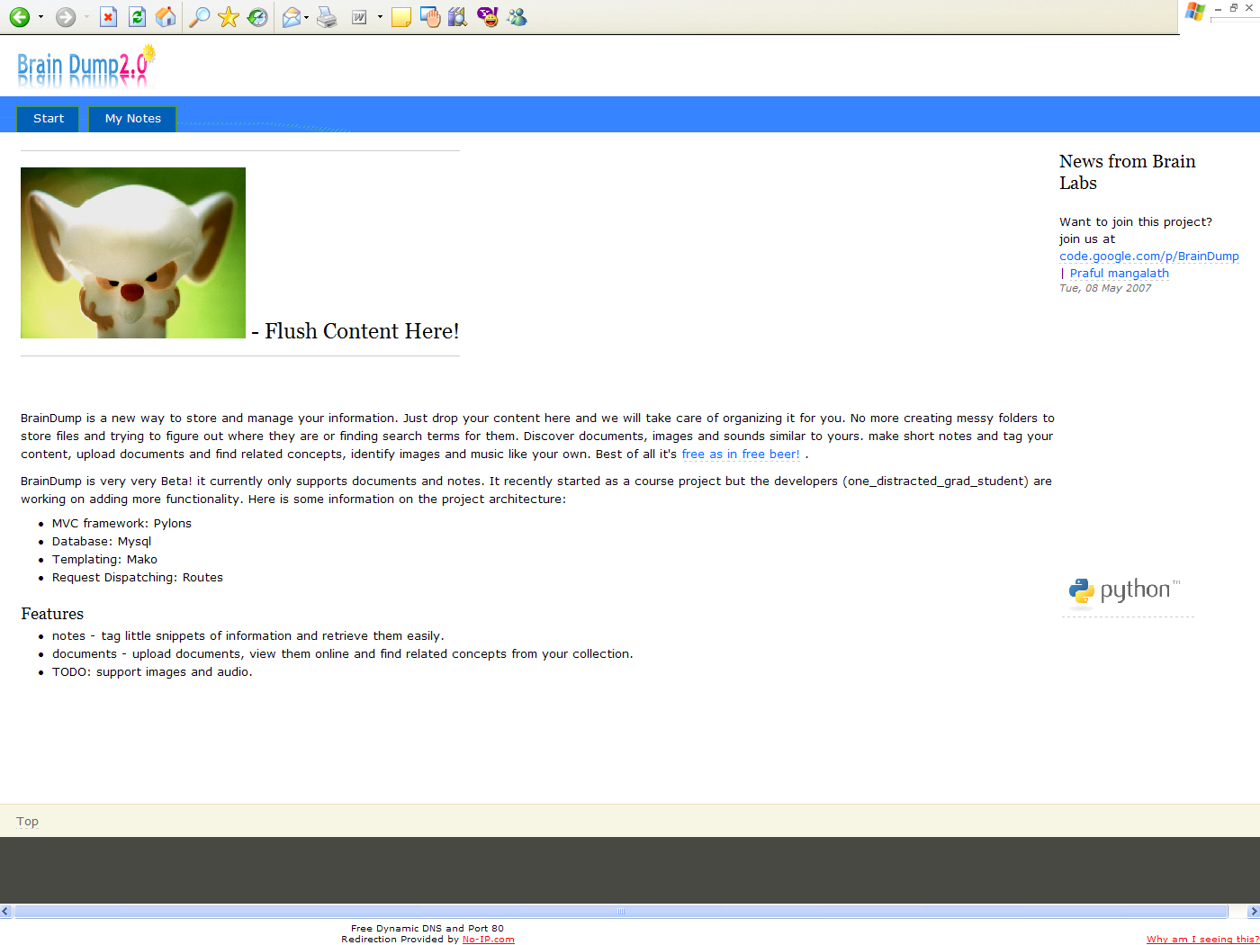
The prototype allows users to upload content (notes, xml files from the sketching, chat sessions, open document format documents etc) and tag them with concept tags that capture the summary of the content.
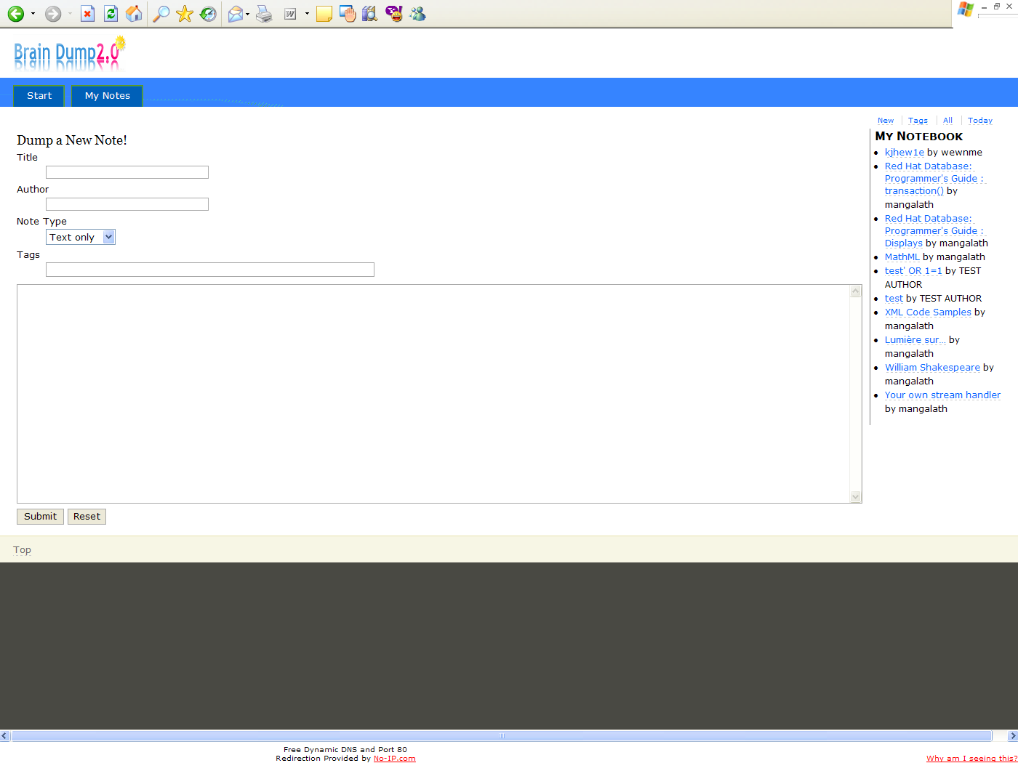
The site also implements a negative captcha scheme so that users need not register to upload or view content – allowing a session to be distributed as a simple url’s. The intuition is that this threshold lowering also encourages more participation. The documents can be viewed as snapshots inline or as complete documents online – either way the content does not leave the browser and encourages more participants to look into other contributions.
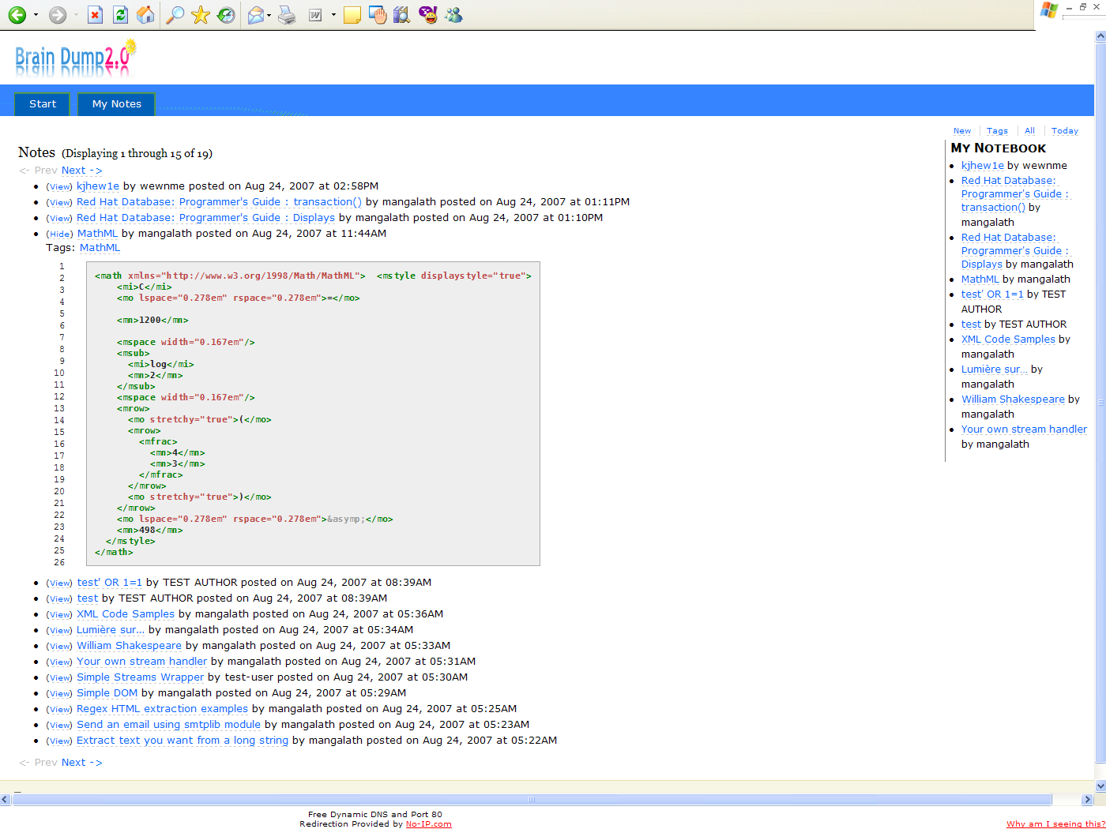
The concept cloud also allows the most popular concepts from a brainstorming session to be viewed and track all content related to these tags thus building this ability to poll for ideas naturally.
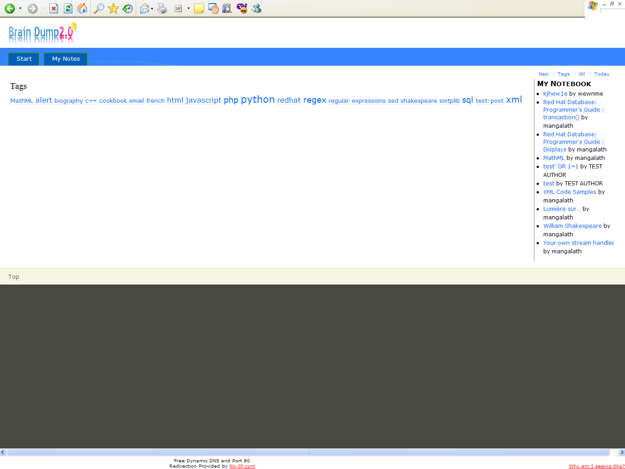
The image below shows all content tagged with tag ‘python’.



