Designing Environments for Brainstorming
Yingdan Huang
Peng Michael Shao
Praful Mangalath
Chen-Chung Liu

Introduction

Brainstorming is a collaborative process for generating, collecting and filtering ideas. We are looking at environments that facilitate this process. The project initially started off as a follow up to our independent study proposal wherein the emphasis was on ‘board/sketch’ type environments for initial phase collaborative design – hence named Design Brainstorming Board. The study was looking at synchronous multi-user design environments trying to identify specific features that were lacking. The results of the study however revealed that there was in fact no shortage of features – almost every product we analyzed used dollops of the latest and greatest ajax/java hackery to deliver almost ‘seamless’ synchronous sketching, private and public spaces, chat dialogs, video and voice capabilities.

We decided to take a humbler approach to the project and not join the feature bandwagon. We conducted an experiment, a traditional brainstorming session where the participants were face-to-face, to gain insights into features that may have been overlooked and define a narrower problem statement. The results of this experiment are discussed in the section ‘Brainstorming Experiments’. Although we were unable to reach a unified specification that we could collectively work towards, the evidence indicated that there was indeed a huge disconnect between ‘environment supported brainstorming’ and ‘in person brainstorming’. We have decided to focus on two approaches to designing environments that support brainstorming. The first looks at synchronous media rich audio-visual environments and the other an asynchronous wiki based approach to collaborative design. We present some theoretical background behind these motives and our progress thus far in this report.As the integration team, with the topic “Design Brainstorming Board to Aid Early Design Communication”, we should admit that we are very ambitious since the research task is related to three large domains: early design, collaborative design and brainstorming even though we try to focus on their intersection part. Later we simplified it as “group brainstorming to start a design process”. As to the “DLC” class, except for design and collaboration, which are our study, three (four) of us learned from our team work as well as from other groups.

Collaborative processes and Brainstorming

Collaboration is a rather ambiguous term and in the scope of this paper we restrict its context to the process of interaction between two or more people. Synchronous collaboration here refers to the process of interactions between people in real time or an interaction where the participants are available during the timeline of the interaction (video-conferences, instant messaging). Asynchronous collaboration relaxes these constraints and allows participants to interact at timelines convenient for them (email, wiki’s)

Brainstorming involves both idea generation and idea reduction. The most creative, innovative ideas often result from combining multiple, seemingly unrelated ideas. Although brainstorming emphasizes the generation of deliberately many unusual solutions from a group for a particular problem so as to play off associations within this pool and expand and develop new ideas toward the goal, it was only intended as a supplement to individual creativity and not a replacement.

A typical in-person brainstorming session comprises a group of 2 or more people working in a room with some supplemental aides like whiteboards, post-its and forms of audio/visual equipment. A lot of research has focused on the effectiveness of this group synchronous approach compared to a pooling the results of the individual participants independently. Although the metrics used tend to not capture the complete dynamics of group interaction (number or ideas generated, quality of ideas generated), there is significant evidence that shows the effectiveness of individual efforts pooled together with a moderator managing the role of bringing independent information together into a coherent discussion (Diehl & Stroebe, 1987; Dennis et al., 1996, 1999).

Instinctively, people feel that working in a group has an advantage over working individually on many creative tasks. However, research with laboratory groups has consistently shown that on brainstorming tasks, interacting groups actually underperforms groups of non-interacting individuals. Moreover, in “Brainstorming Groups in Context: Effectiveness in a Product Design Firm”, Robert I. Sutton pointed out that “Experimental research indicates that people in face-to-face brainstorming meetings are less efficient at generating ideas than when working alone”. But in “Managing Software Requirements: A Unified Approach”, the author mentions live brainstorming is preferred in a way like it is a common sense. These findings raised two questions:
- Someone might make a mistake and there could be errors existed in a formal publication;
- What’s more important is who we should believe and what is the fact?

Considering the sources of references, we have reasons to accept the facts that group brainstorming is less effective than individual brainstorming in practice. Despite these findings, we believe that interacting work groups in organizational settings may be able to achieve high quality creative outcomes, where the keywords are “organizational settings”. And we feel that exploring online wiki environments and supplementing them with rich media capabilities that enhance collaboration has the potential to provide us with these settings.

Environment Design

Collaboration amongst distributed work groups in organizations has become an increasingly common task. We explored existing approaches to environments which support this distributed effort and found that although feature rich they seemed like an ad-hoc mashup trying to tailor to every corner of the brainstorming spectrum. We are obviously restricted heavily on time and hence decided to focus on some simple aspects we felt were important.

When we were exploring the collaboration mode, we developed a Java applet (https://webfiles.colorado.edu/huangy/www/myApplet.html) to compare with “Group Scribbles”, which was introduced in one class and was cited by people often. Figure1. shows an evolvement of collaboration models, including our analysis to “Group Scribbles”, while when we consider how users possibly and practically work together over the internet, we need the aid of programming to visualize and simulate what it is. We made many assumptions (some assumption can be extended as interesting research questions) to simplify the collaborative model as well as to make our points:
- Collaboration over internet is much more flexible and dynamic regarding to meeting time and relationship.
- We need not only public and private space but also semi-public/private spaces, which are necessary for design purpose and reflect actual collaborative activity online.

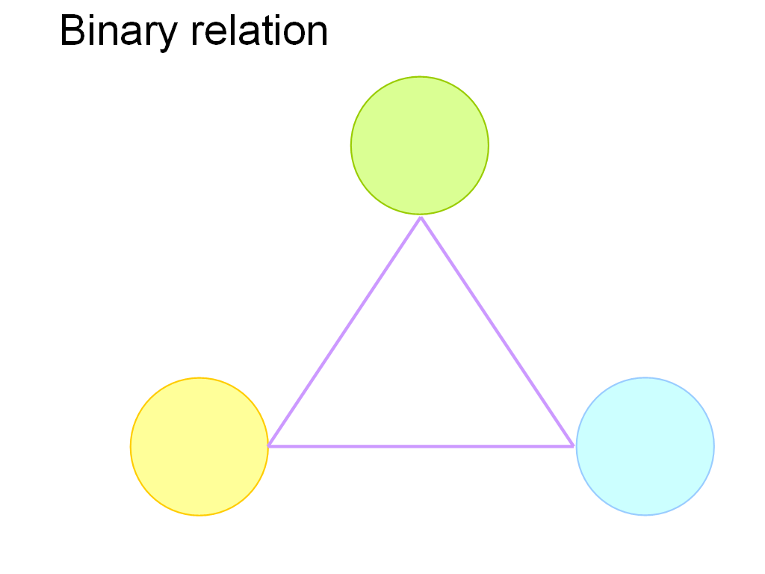 | 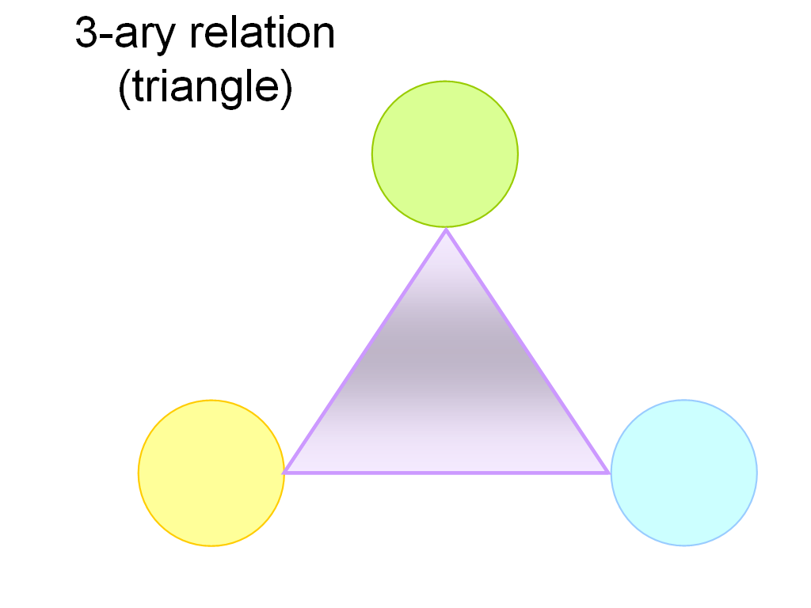 | Figure 1. Collaboration Models  1. Binary relation  2. 3-ary relation (triangle)  3. 3-ary relation with public/private space  4. 4-ary relation (tetrahedron)  Note: 3-4: Collaboration model of Group Scribbles
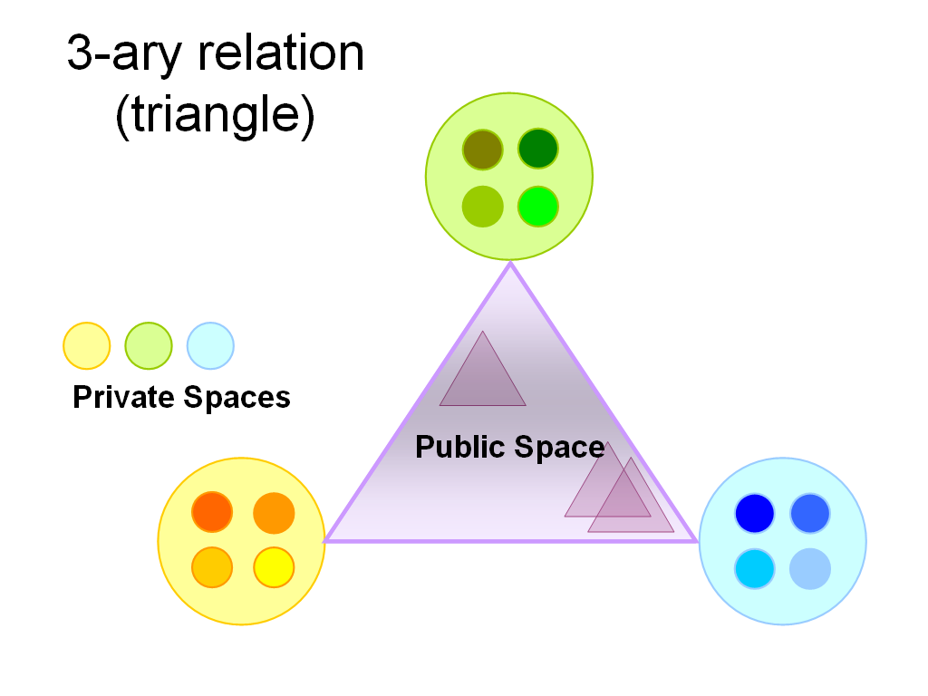 | 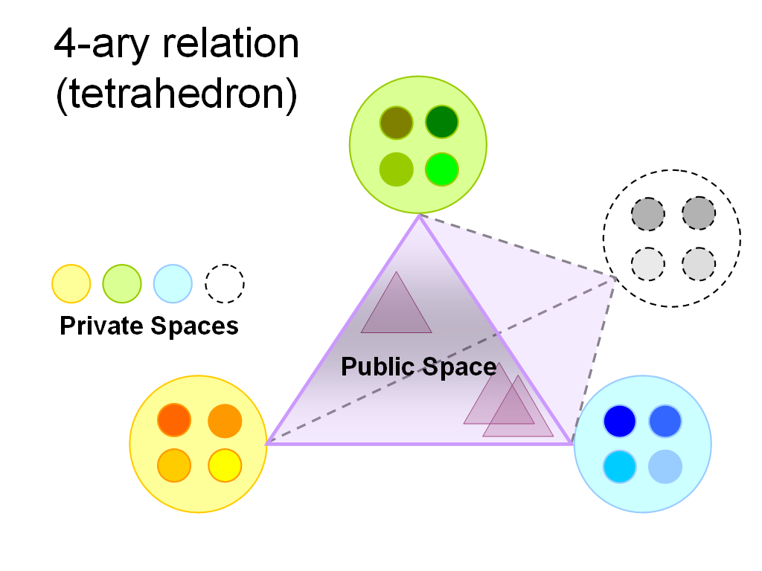

The selected design process follows a hands on task based approach looking primarily at the brainstorming process itself as an idea collection and organizational task in the seeding, evolutionary growth, reseeding (SER) framework (Fischer, 1998) . A facilitator seeds an editable page with the topic/goal and some background information. Participants are then invited to contribute to the goal – this can be done either by directly editing the page or uploading content onto the page. The participants can comment on any of the ideas updated on the site initially in an un-moderated manner and also have an option to vote up/down ideas they felt were particularly good/bad. The facilitator moderates the session by selecting content and reseeding the wiki at several stages with content filtered from the opinion polls. A simple wiki tailored to this sort of discussion is being implemented along with supplemental products that add rich media into the discussion. More details on the actual implementation will be included once the limitations are worked out.

Design Concept: Early Design

Design is presented as an iterative top-down and bottom-up process that induces the emergence of desirable properties. Pahl and Beitz (1996) write:

“Analysis is the resolution of anything complex into its elements and the study of these elements and of their interrelationships. It calls for identification, definition, structuring and arrangement. The acquired information is transformed into knowledge.

Abstraction gives the possibility of finding a higher level interrelationship, that is, one which is more generic and comprehensive. Such a process reduces complexity and emphasizes the essential characteristics of the problem and thereby provides an opportunity to search for and find other solutions containing the identified characteristics. At the same time new structures emerge in the minds of designers and these assist with the organization and retrieval of the many ideas and representations.

Synthesis is the putting together of parts or elements to produce new effects and to demonstrate that these effects create an overall order. It involves search and discovery, and also composition and combination. An essential feature of all design work is the combination of individual findings or sub-solutions into an overall working system – that is the association of components to form a whole.”

We would consider analysis as a top-down process, synthesis as a bottom-up process and abstraction can be any level in between. As for designing a building, we could analyze usage of each space, aggregate spaces of similar purpose into zones (abstraction) and integrate them into a whole design (synthesis) and it is not rare to perform a same design in a reversed order or start it from a middle level.

For early design, what we are interested are how people start thinking and communicating? And the very beginning of the design process, have computers already given enough support? If the answer is no, what can computers help? With these questions, we have done experiments on brainstorming sessions and surveys for several current software or platform which claim to support for this intention.
Brainstorming Experiments

Scope of Experiments

Group brainstorming is a vast, rich, and complicated subject area. We conducted two experiments in an isolated setting that explored group brainstorming of the synchronous, localized, and short-term nature. The discussions were of an improvisatory nature – that is, the participants (called “individuals” for this set of experiments) had no knowledge of the brainstorming topics beforehand. The individuals ranged from college students to PhD students to faculty in Computer Science – all had some knowledge of the domain. We came into the experiments with the idea of assimilating key characteristics of collaborations of this kind. We then attempted to apply these characteristics to redesigning the concept of online brainstorming.

Experiment 1

The task was to redesign the L3D lab space. There were four individuals in this group, each was given a specific color of Post-It pad. In 15 minutes, individuals were asked to think about the redesign on their own, sketch a version of their desired L3D space on their Post-It pads, discuss their own solutions, and then attempt to reduce the conversation down to a few key points that could be submitted, for example, as a draft proposal for redesign of the L3D lab space. There was a moderator who asked questions and prodded the group to move on to the next phase of the experiment.

Observations from Experiment 1

In the span of 15 minutes, the group was able to reduce the collection of individual proposals into a set of key points that they could submit as a proposal. The individuals came at the problem from different motivation angles: one individual was concerned with Feng Shui, while another individual was considered with having a common coffee and food area. Also, the individuals modeled their solutions in different ways: one individual combined different color Post-Its to form a “large Post-It” version of the L3D lab space, while other individuals stuck with their own color and Post-Its. Finally, the individuals benefited from localization: there was a lot of glancing over to “neighbor Post-Its” and plenty of discourse about idea reduction.

Experiment 2

The task was to redesign the mouse (which subsequently turned into a redesign of the keyboard). There were three individuals in this group, each was given a set of colors in their Post-Its. The difference between this and the first experiment was that individuals were not given a private reflection time, and were asked immediately to commence discussion over the topic of the experiment. Like the first experiment, the end deliverable was a draft proposal for the redesign of the mouse (later, keyboard). There was not a moderator for this experiment, although there was a designated note-taker.

Observations from Experiment 2

From the beginning this experiment had a completely different nature than the first experiment. The conversation was dominated by one individual, who came up with plenty of ideas, asked lots of questions, and initially went off-topic – not long after the discussion began, this individual talked about 3D displays and 3D navigation. This individual had to be brought back on-topic by another individual in the group. In the course of the discussions, many ideas were generated and lots of questions were asked. However, these questions were more of the micro- nature and not of the macro- nature. (questions of the type, “what about this detail here?”) This led discussion to settle into one area or another; therefore, the overall discussion did not represent the ideas of all the individuals.

Preliminary Analysis

Based on the observations from Experiment 1 and Experiment 2, our group came up with a preliminary list of “should haves” for prospective online brainstorming applications:

• Start with individual brainstorming, then presentations, then group brainstorming, then group idea reduction.
• Support different kinds of representation media (text, various sizes post-its).
• Support rapid iterative drafting.
• Support observation of other individuals during individual brainstorming.
• Support constant feedback loops.
• Support audiovisual communication, especially during group brainstorming.
• Support note taking distinct from sketches.
• Support a public workspace (whiteboard) in addition to private workspaces (desk).
• Support colors insofar as it tracks each individual’s contributions.
• Support the presence of a moderator to maintain discussion focus.

Discussion (Constraints)

This was a relatively informal experiment exploring the characteristics of a narrow scope of group brainstorming activities. The brainstorming activities here were of the synchronous, localized, and short term nature. Furthermore, our discussions were improvisatory – the participations had no knowledge of the discussion topics beforehand. Additionally, the involved participants were all college-educated and had some domain knowledge from the DLC graduate course. It is outside of the scope of these experiments to comment on asynchronous online brainstorming, however, it would be interesting to conduct further experiments to discern the effects of synchronization on group brainstorming.

Group Creativity: Innovation through Collaboration, Edited by Paul B. Paulus and Bernard A. Nijstad
Brainstorming Groups in Context: Effectiveness in a Product Design Firm, Robert I. Sutton, Andrew Hargadon, Stanford University
Managing Software Requirements: A Unified Approach, Dean Leffingwell, Don Widrig
“Complexity science in collaborative design”, Jeffrey Johnson, CoDesign, International Journal of CoCreation in Design and the Arts, Vol. 1 No. 4, Dec. 2005
Pahl, G., Beitz, W. (1996) Engineering design: a systematic approach, Springer-Verlag (London).

